Point at Site | Position | Date and time Warning Notices were affixed to the site
Access A  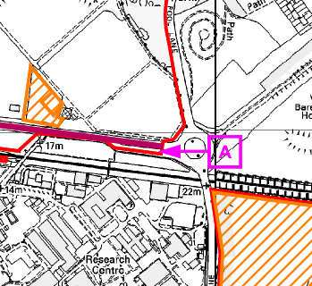 | 1x Warning Notice displayed on the boundary line at access point A
 | 1x Warning Notice attached to gate leading from access point A into the site
Access B (Gate 6)  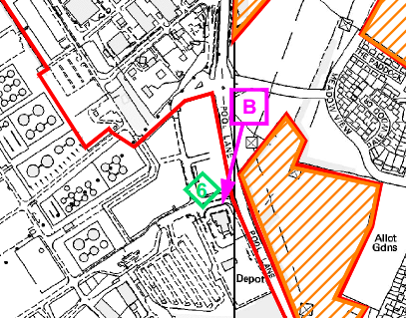 | 1x Warning Notice attached to the fence at Access point B (Gate 6) off Poole Lane
Access C  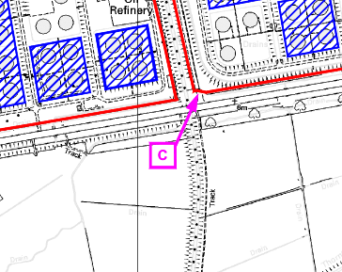 | 1x Warning Notice attached to right hand side of the white fence at Access point C off A5117
Between Access B and Access C  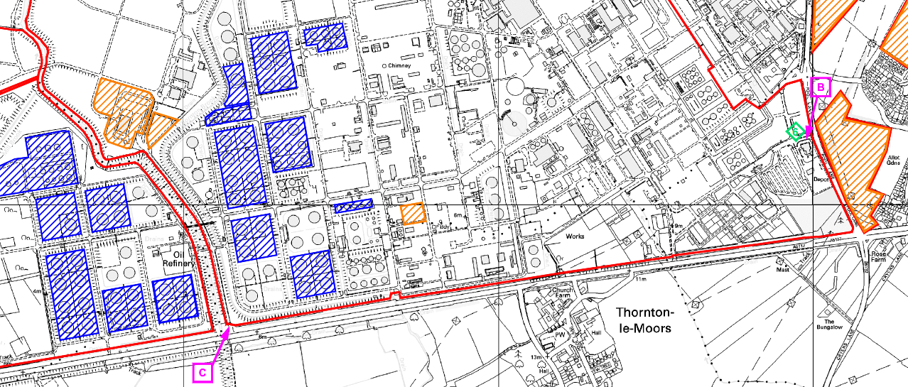 | 2 x Warning Notices attached to boundary fence visible from the highway (A5117)
Checkpoint at layby off yellow access on Oil Sites Road  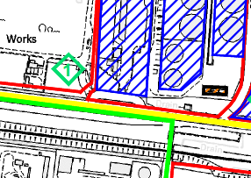 | 1x Warning Notice located at checkpoint off yellow access along Oil Sites Road
Access gate off Mill Lane | 1x Warning Notice affixed to access gate at rear of Lexus Dealers
Access off Kinsey’s Lane behind Yewtree Farm  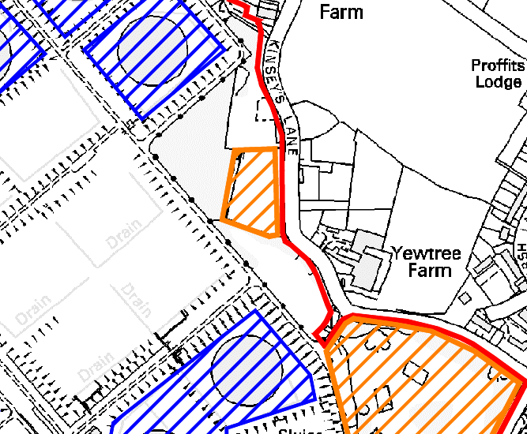 | 1x Warning Notice affixed to site off Kinsey’s Lane behind Yewtree Farm

